Tat-Tokod - project
2016. november 18. 10:20 - admin
Workshop and study tour: Water and environmental monitoring and mitigation measures with multifunctional blue-green areas for flood control and improving water quality: examples constructed ponds and wetlands and restoring urban water ways in Norway
April 20-21, 2016

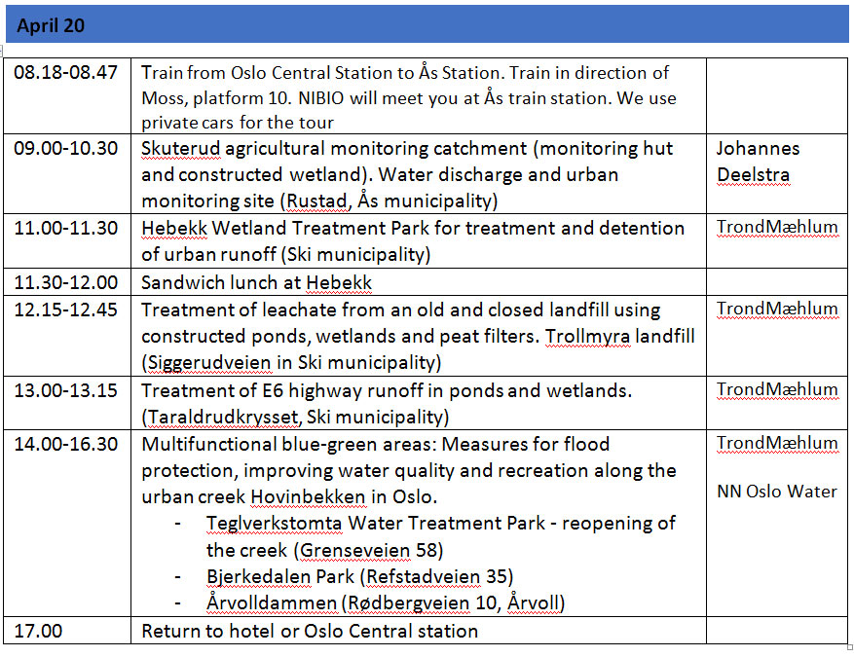
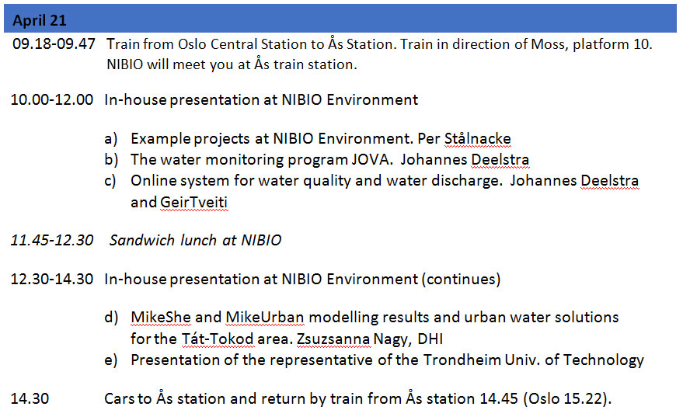

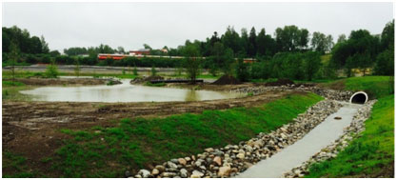Hebekk Wetland Treatment Park in Ski
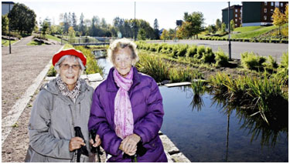
Two neighbours of Bjerkedalen Park, the winner of Oslo City architect competition 2015

