Project closing event at Tát
2016. november 17. 08:31 - admin
Project closing event at Tát
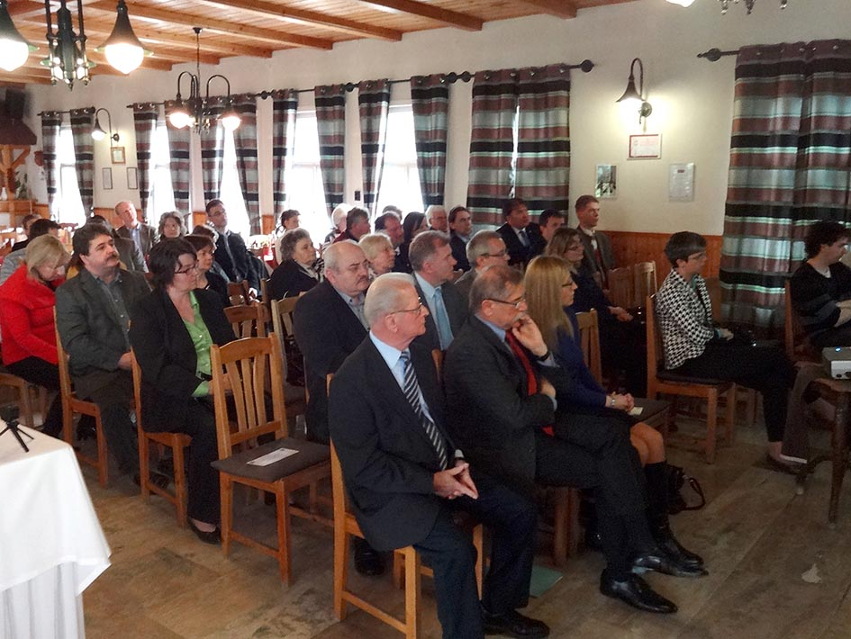
Tát, 23 March, 2016
Inland inundation caused by a variety of factors has been a problem in the settlements of Tát and Tokod for a long time. More and more often, the high level of ground water presents challenges in our settlements as a result of changed circumstances in the climate. Due to climate change, extreme weather conditions are expected to be even more frequent and aggravate problems.
The two local governments involved in this development started to tackle this recurring and crucial problem in the framework of the present project. The closing event of the project took place on 23 March 2016 in the Hotel „Öreg Halász” („Old Fisherman”) at Tát.

Project closing event at Tát

